A000-Am,C-Cemi-Kingfisher-Bulging Eyes-Green Serpentine-1000 CE

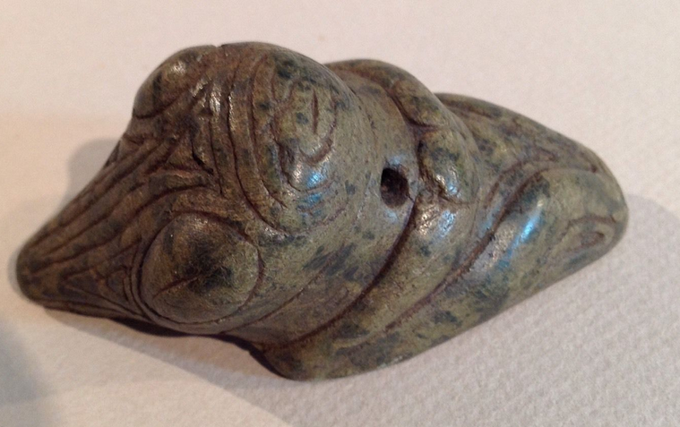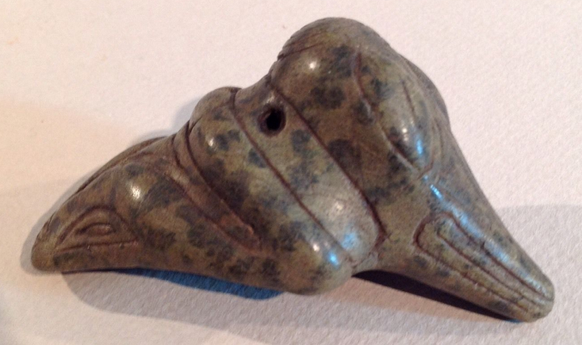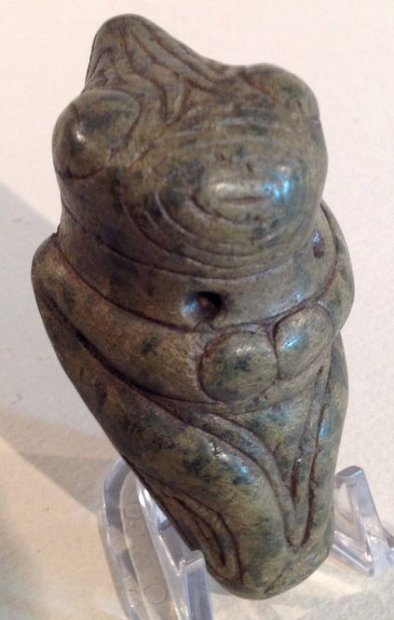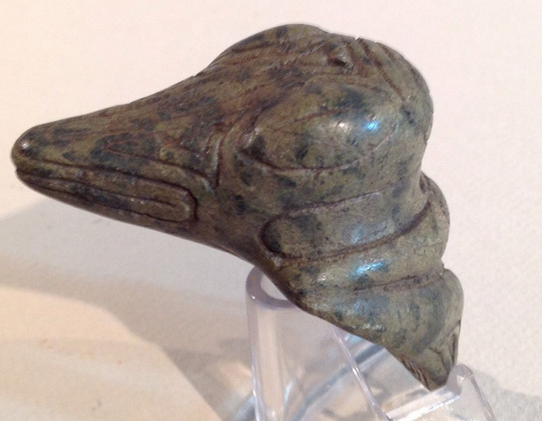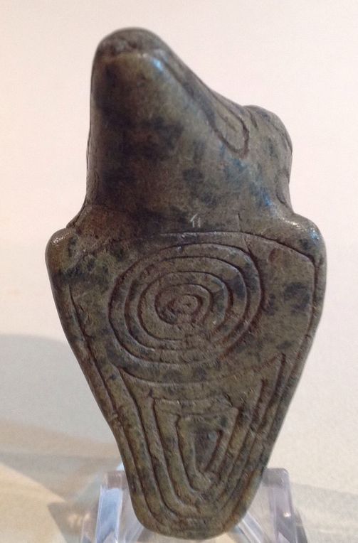

Am,C-Cemi-Kingfisher-Bulging Eyes-Green Serpentine-1000 CE

**Case No.: 18**

**Accession No.**

**Formal Label:**

**Display Description:**

Because of its size this pendant was probably a point of focus piece used at specific ceremonies where Kingfisher allies were called upon for their knowledge of diving into the cosmos. Made of a green spotted serpentine. It has large coffee bean eyes and is well engraved with symbolic icons. An unusual design of a revered bird spirit.

**LC Classification:**

**Date or Time Horizon: 1000 CE**

**Geographical Area:** Originally from the Dominican Republic

**Map:**

**GPS coordinates:**

**Cultural Affiliation:**

**Media:**

**Dimensions:** It measures 8.1 cm. or 3.2 in.

**Weight:**

**Condition:**

**Provenance:**

**Discussion:**

**References:**